**Evaluating Semi-Manual Labeling over the signal and PSD**

This report presents the results of semi-manual EMF signal labeling to evaluate potential precursors of glycemic states based on signal features.

General idea was to use the PSD analysis to extract the manually labeled regions of interest (from the signal spectrograms) to be used to predict future hypo/hyperglycemia events.

* The PSD analysis is done over the preprocessed signals (per patient/channel)
* A simple GUI-based app has been developed to mark the desired regions of interest
* The regions are labeled as “hypo” and “hyper” precursors are marked and saved for further analysis.
* To validate the usability, we have compared the inter-patient accuracy, specificity and consistency of these regions. For example, if a region is labeled as a precursor to hypo/hyperglycemia, we want to see if the other labeled regions, compared by frequency domain feature statistics, such as mean, standard deviation, dominating frequencies, etc, share a similar properties.  
  Two manual labeled regions can be considered similar if they have similar frequency domain features.

**Spectrograms**

On the figures below one may see a signal power spectrum on a log scale, coupled with the raw signal data and CGM values

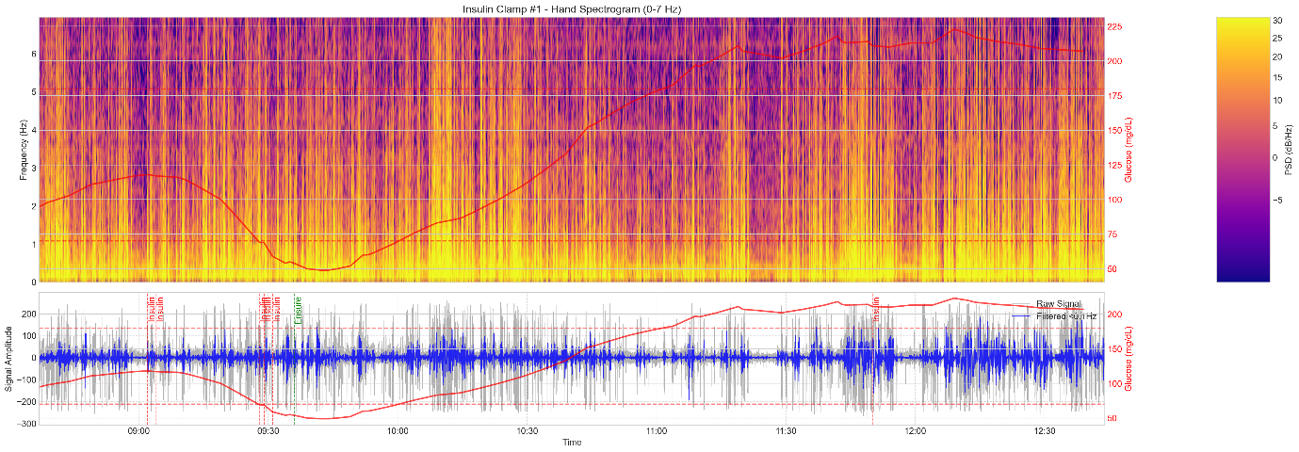

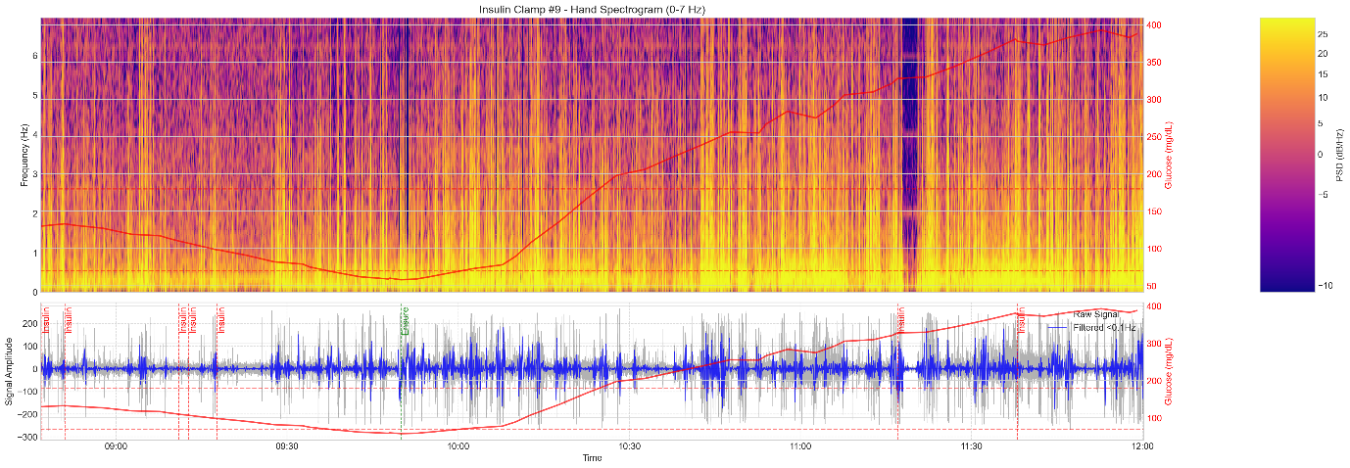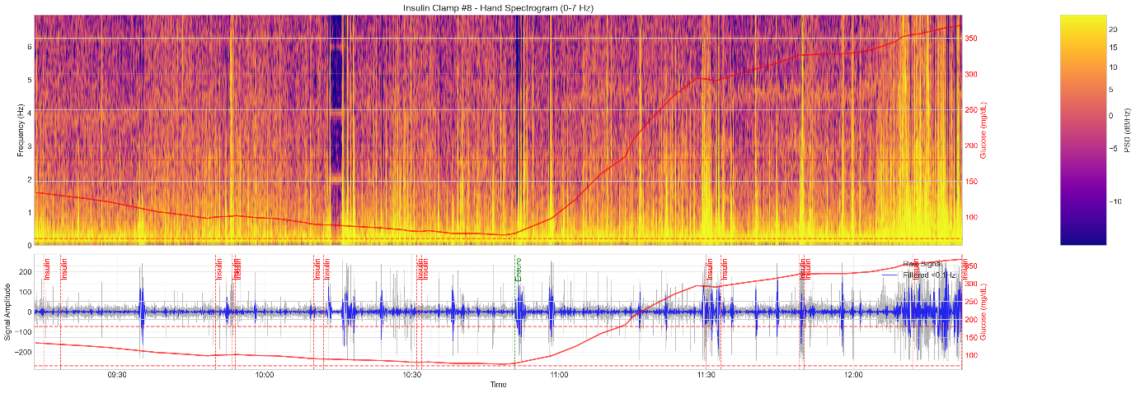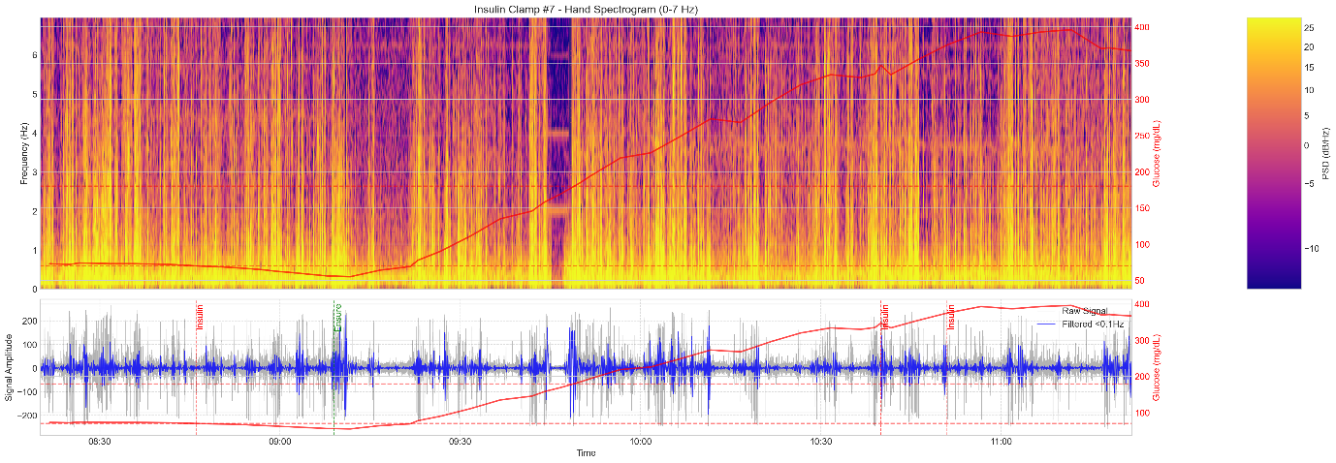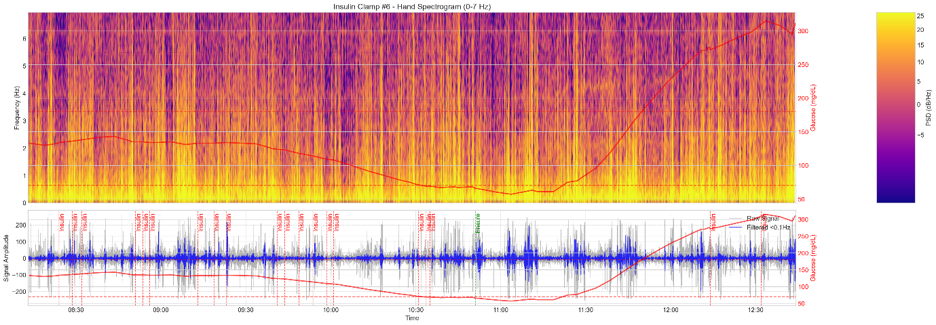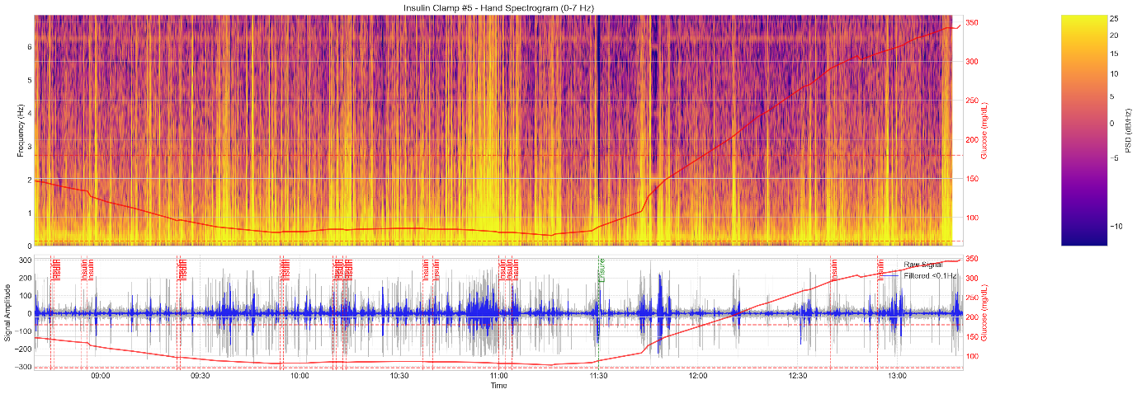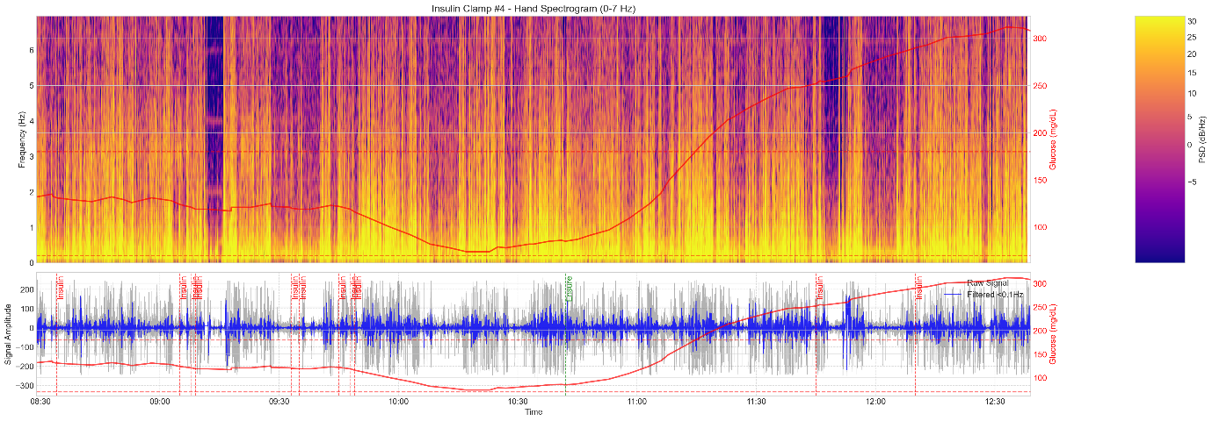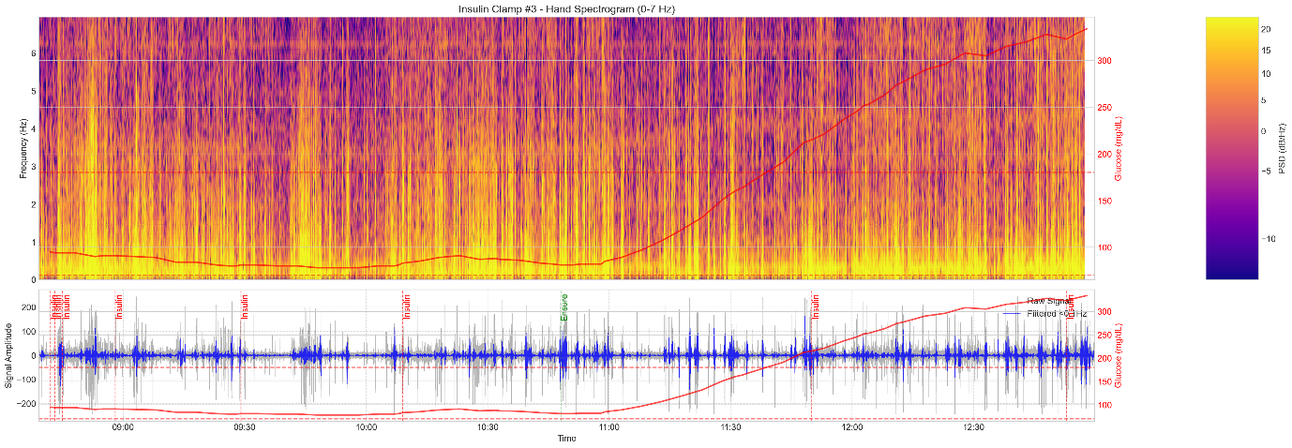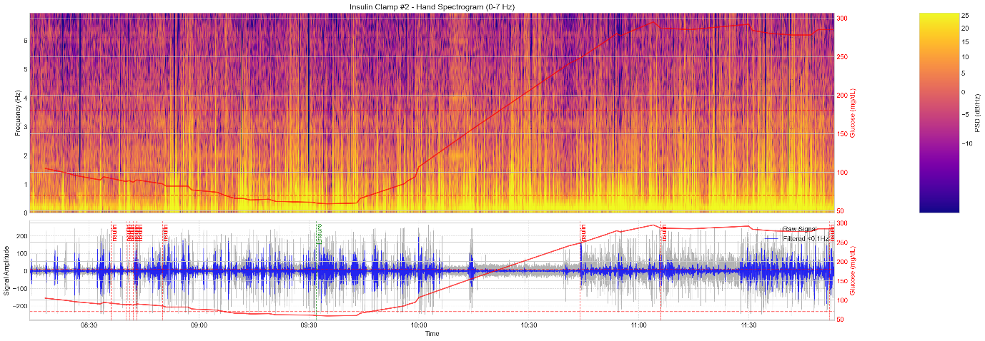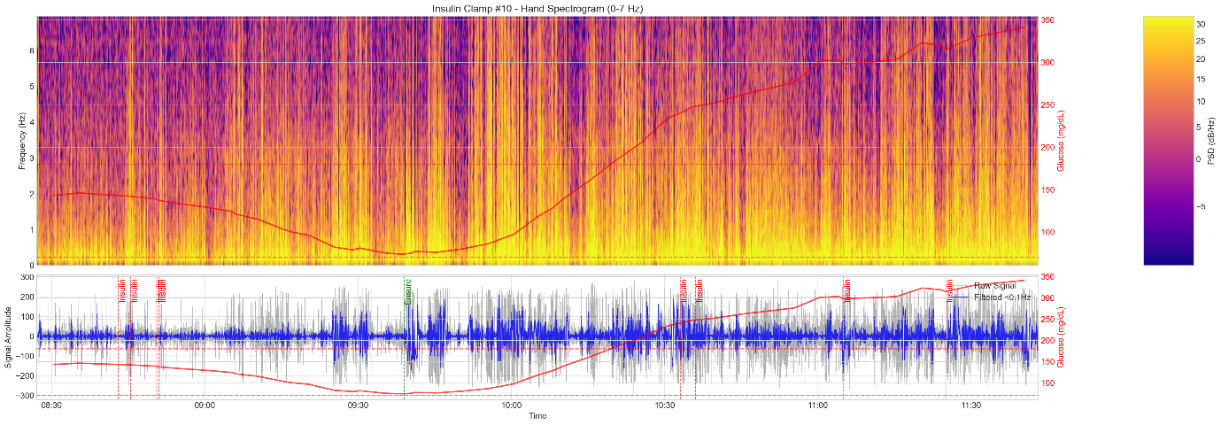

Hi-resolution images for all the patients (Normal and Diabetic) have been generated for all channels and available outside of the scope of this report. 60 Images in total (3 channels x 10+10 patients)

Labels have been manually generated for the “Hand” channel for all the diabetic patients. 138 labeled regions for 10 patients

**Analysis**

Frequency band power analysis has been done to compare spectral characteristics between different event types and control regions for every patient as follows:   
  
1. Loading signal data for a patient  
2. Identifying segments labeled as "hypo precursor" or "hyper precursor" events  
3. Sampling random segments from non-labeled areas as "control" segments  
4. Calculating power in custom frequency bands (0-7Hz in 1Hz intervals) for all segments using Welch's method  
5. Analyzing three key aspects of similarity:  
 - Within-group similarity (how similar segments of the same type are to each other)  
 - Between-group similarity (how similar different event types are to each other)  
 - Similarity to control segments (how event types differ from non-labeled regions)  
6. Performing statistical tests (t-tests) between all group pairs (hypo vs hyper, hypo vs control, hyper vs control)  
7. Creating a summary showing:  
 - Mean power and coefficient of variation for each frequency band  
 - Statistical significance and effect sizes for all comparisons  
 - Most discriminative frequency bands for distinguishing event types  
  
This comparison intended to help us identify class separation quality and characteristic frequency patterns that could be used for early detection or prediction of glycemic events.

Insulin Clamp #1 (Hand) Spectral Power distribution and Spectral Power Profiles: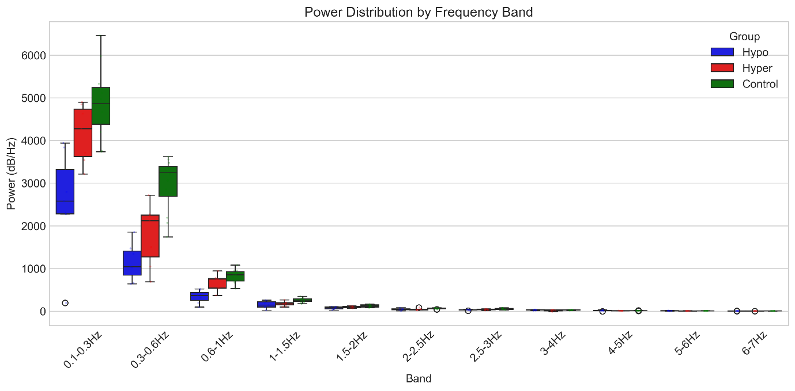

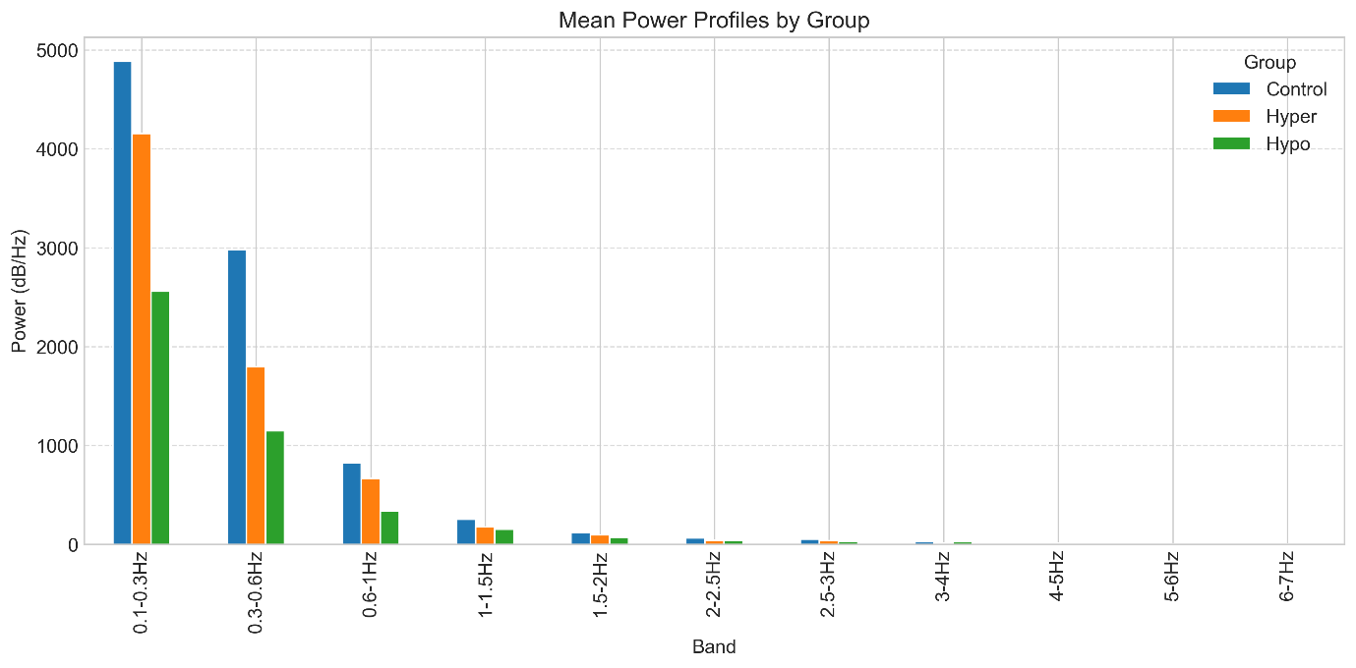

Insulin Clamp #2 (Hand) Spectral Power distribution and Spectral Power Profiles:

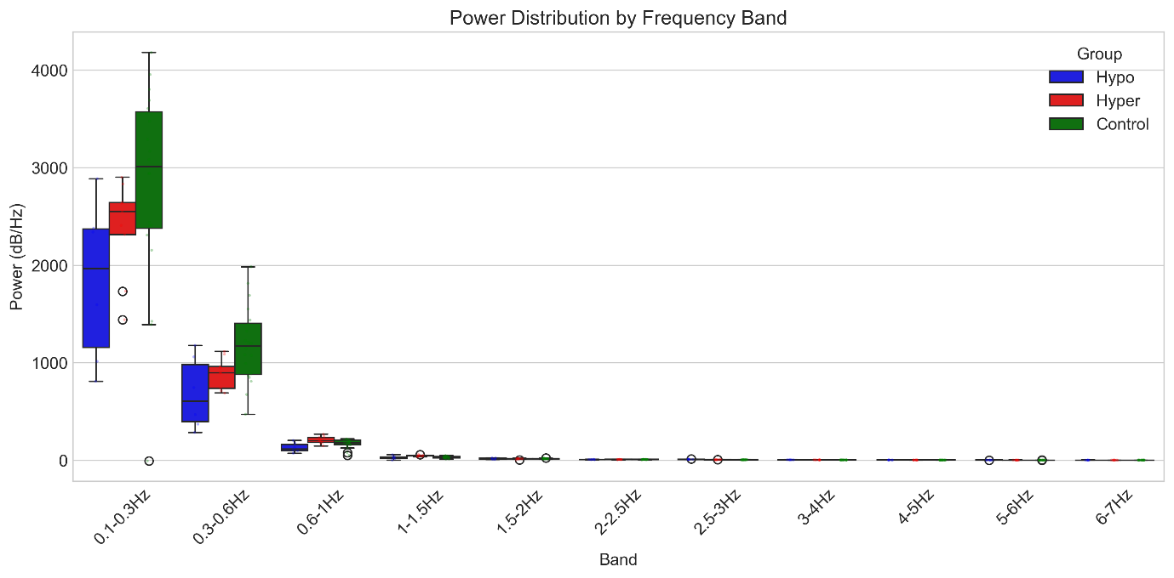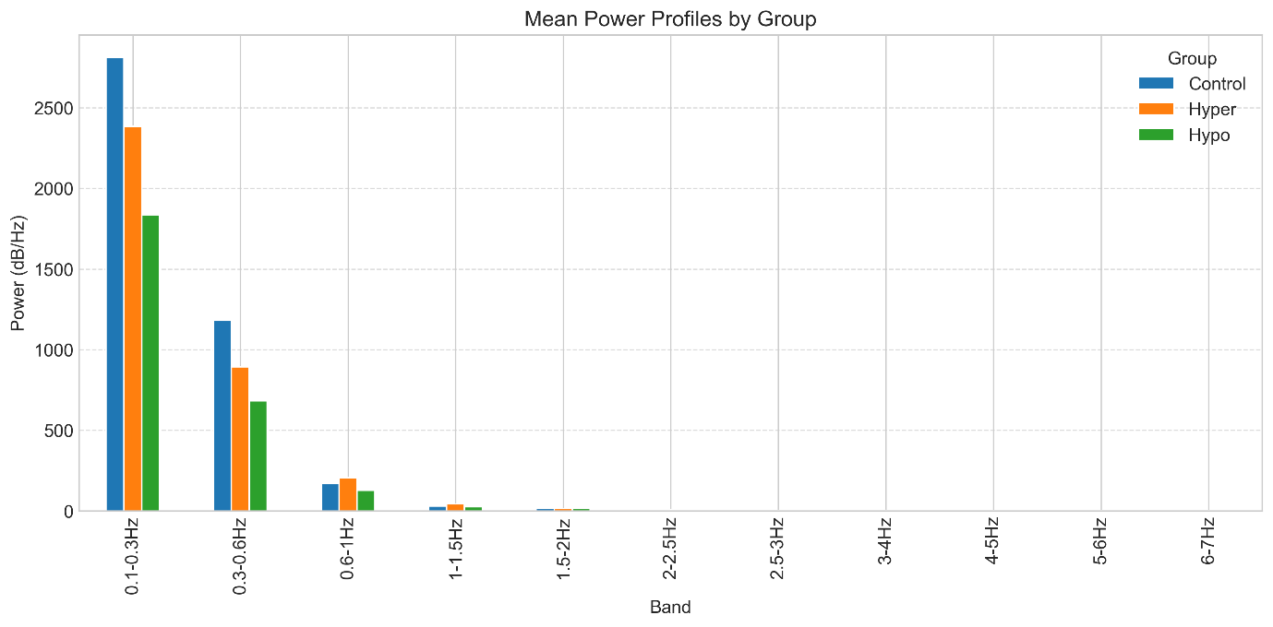

Insulin Clamp #3 (Hand) Spectral Power distribution and Spectral Power Profiles:

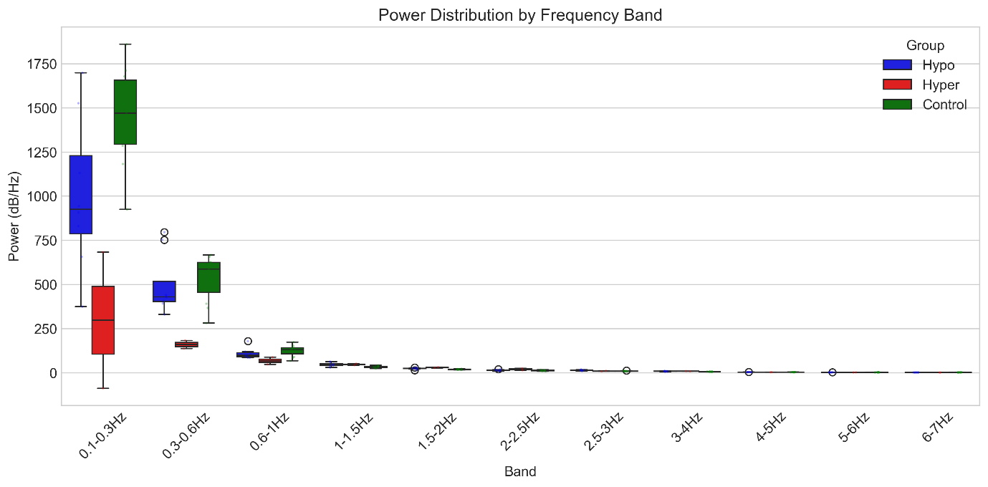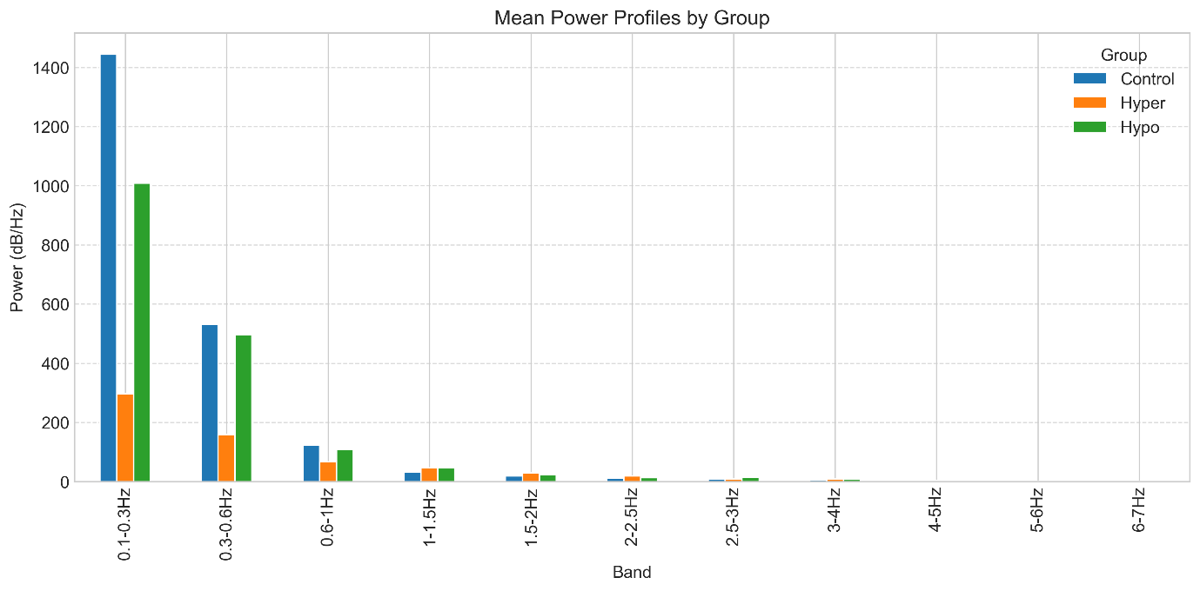

Insulin Clamp #4 (Hand) Spectral Power distribution and Spectral Power Profiles:

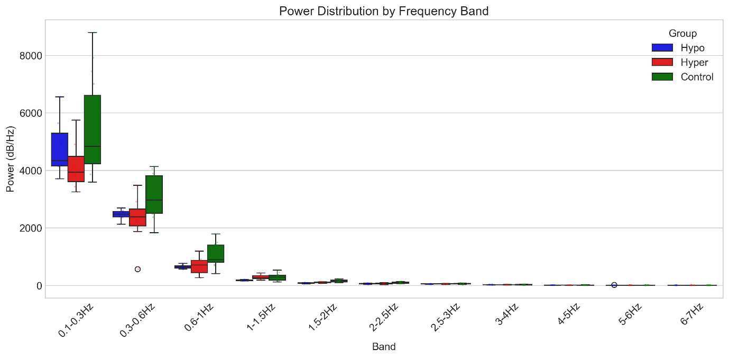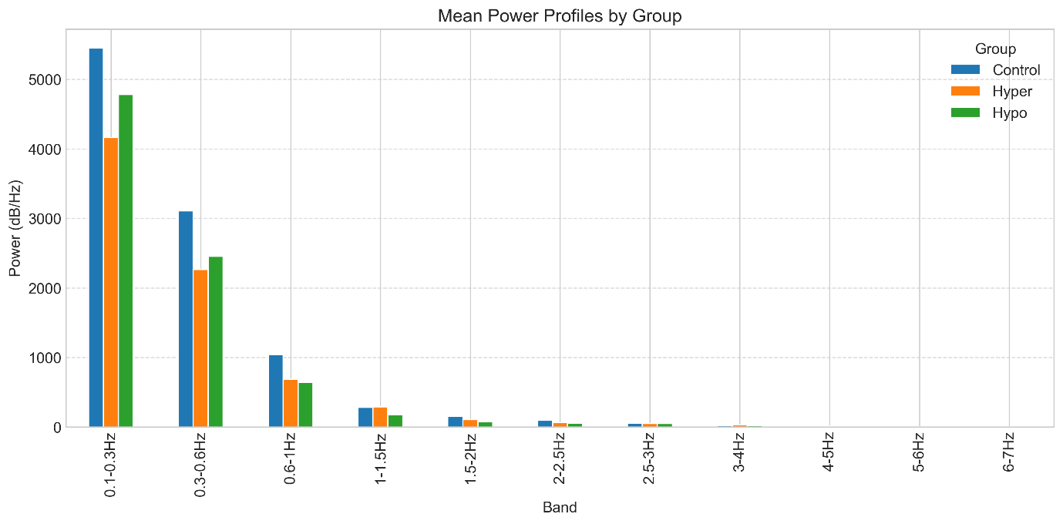

Insulin Clamp #5 (Hand) Spectral Power distribution and Spectral Power Profiles:

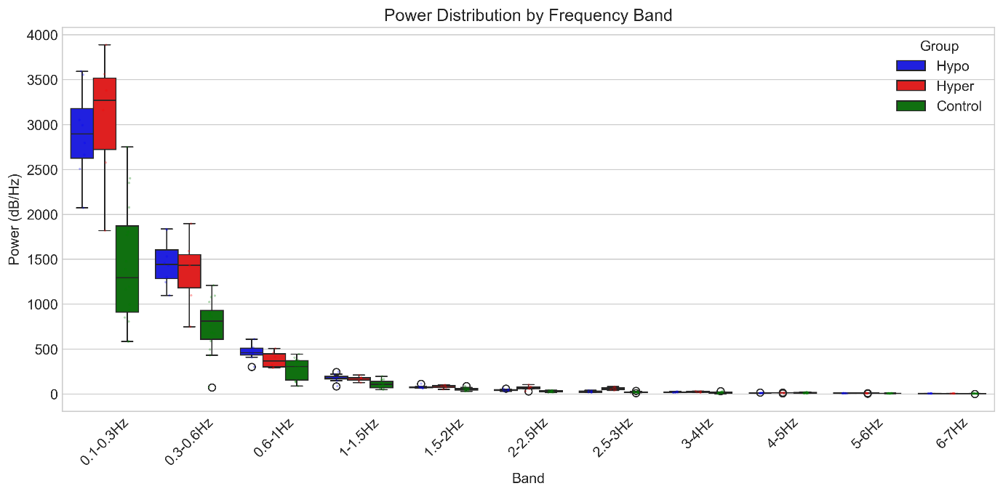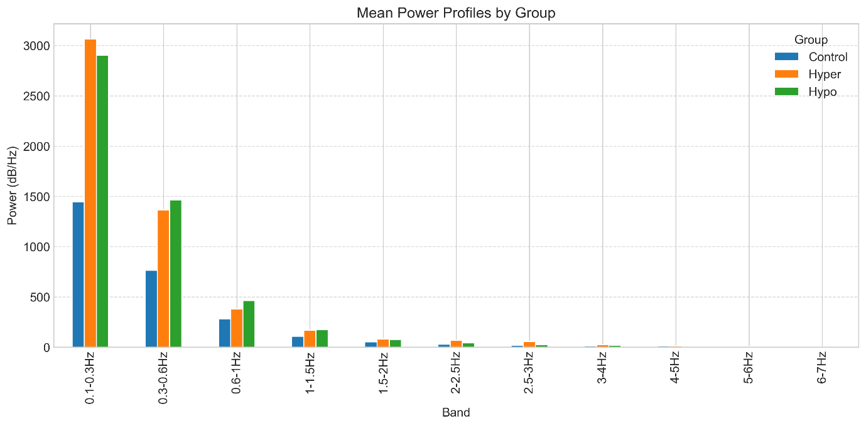

Insulin Clamp #6 (Hand) Spectral Power distribution and Spectral Power Profiles:

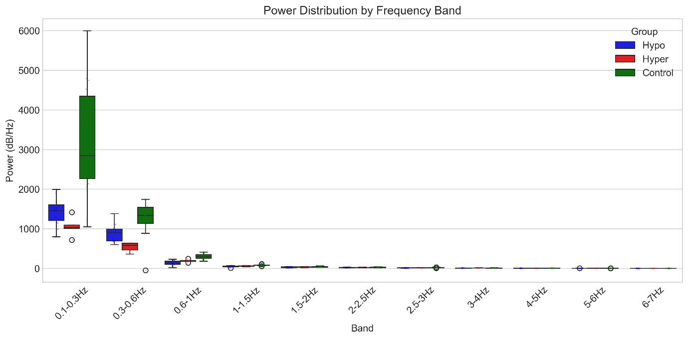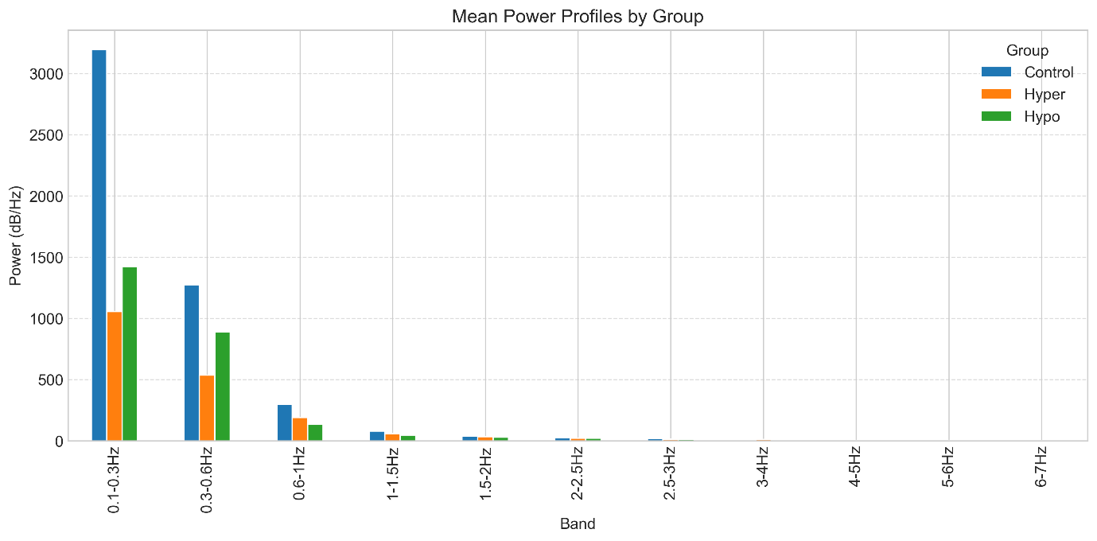

Insulin Clamp #7 (Hand) Spectral Power distribution and Spectral Power Profiles:

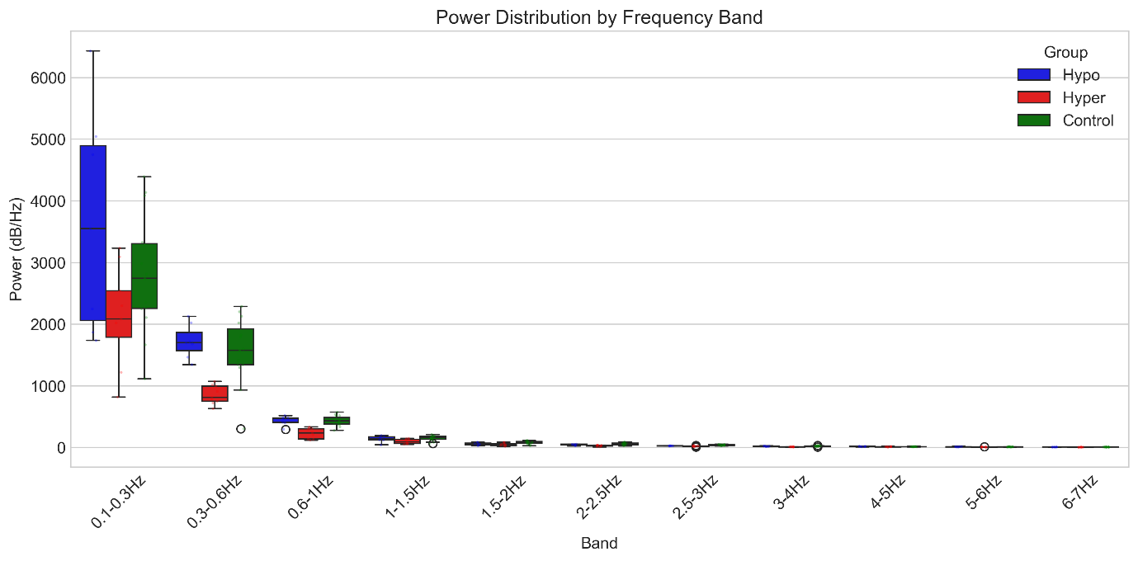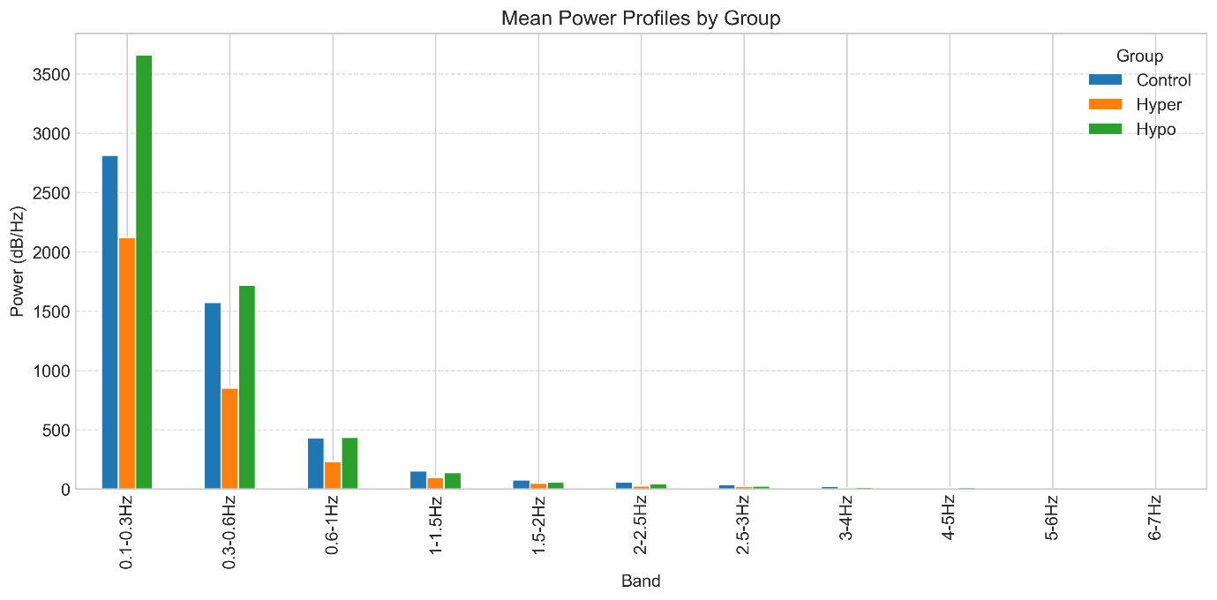

Insulin Clamp #8 (Hand) Spectral Power distribution and Spectral Power Profiles:

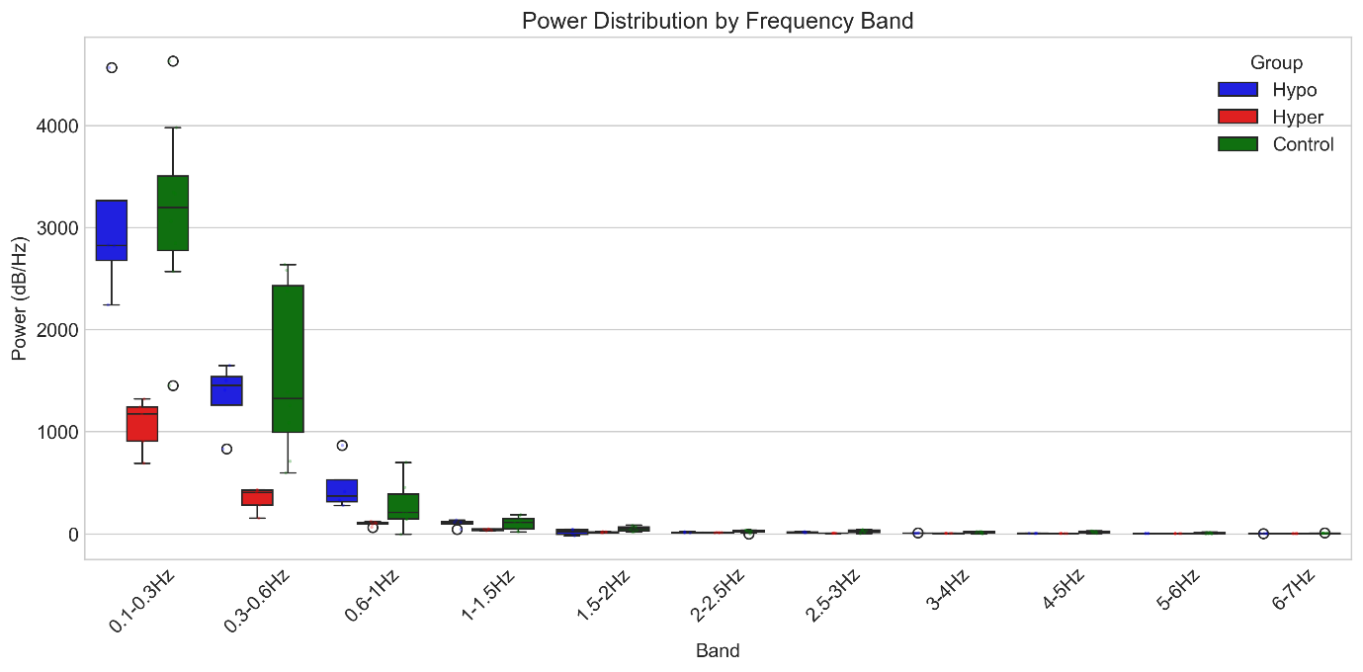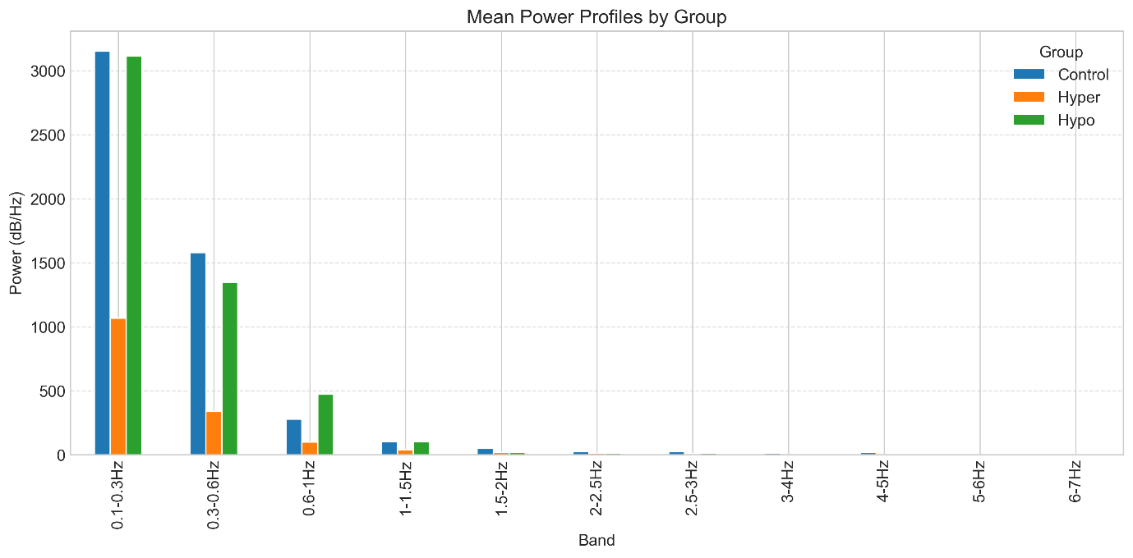

Insulin Clamp #9 (Hand) Spectral Power distribution and Spectral Power Profiles:

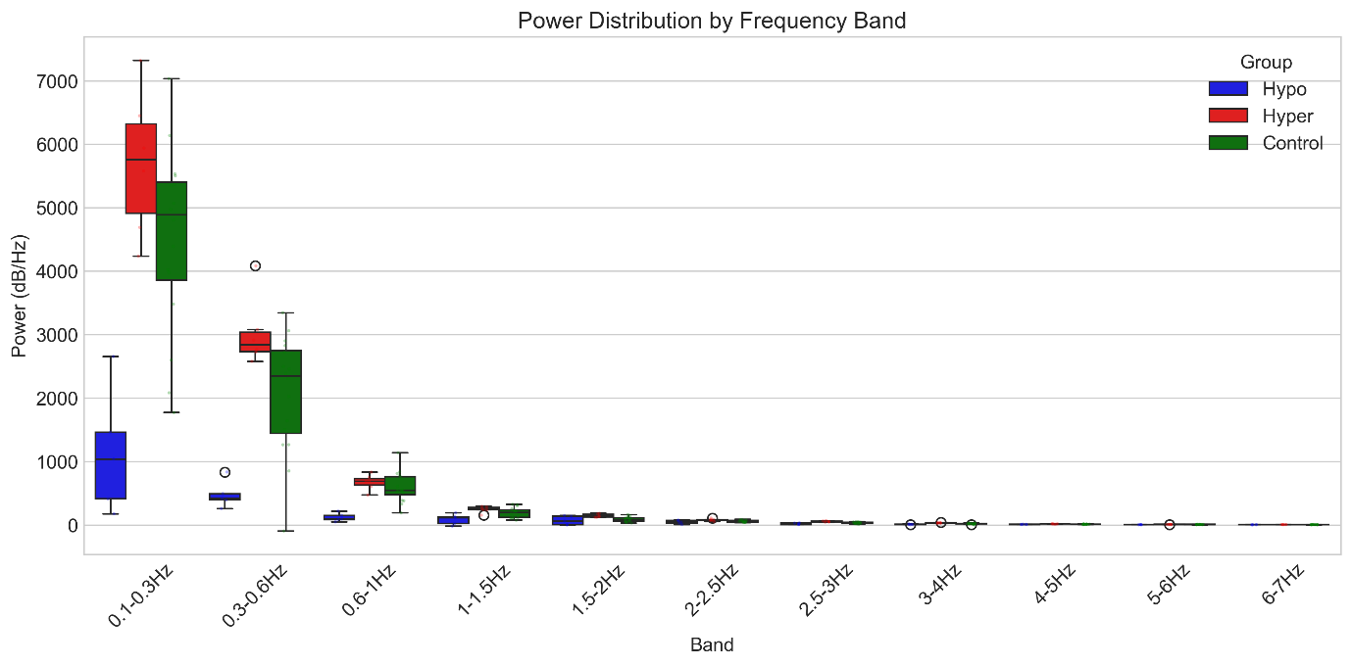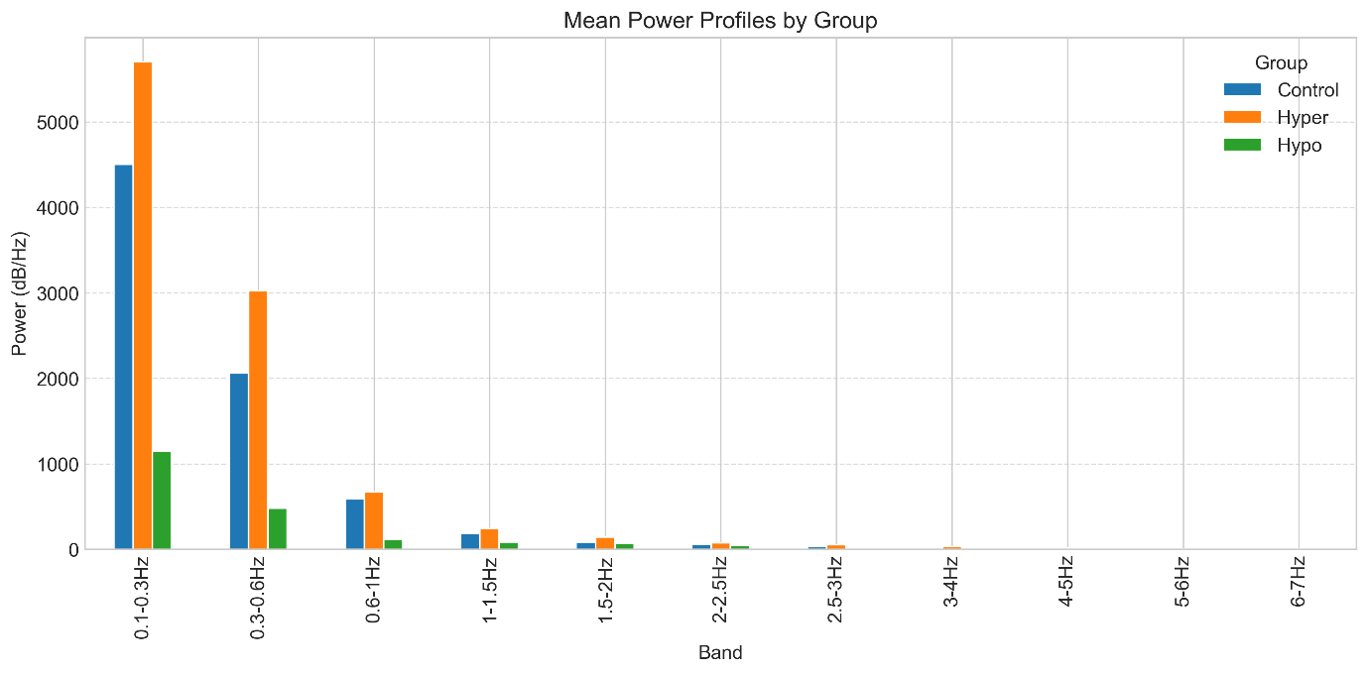

Insulin Clamp #10 (Hand) Spectral Power distribution and Spectral Power Profiles:

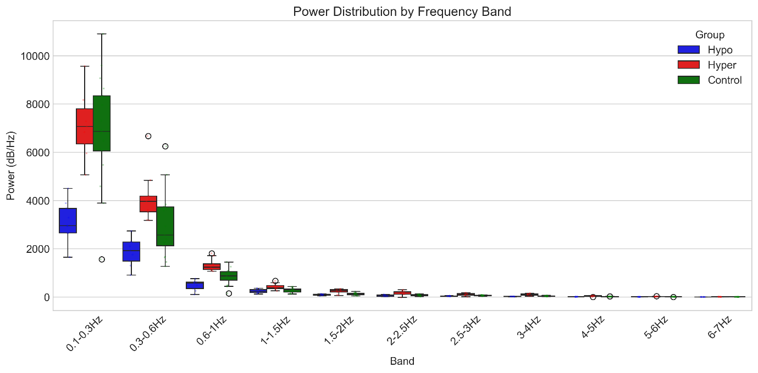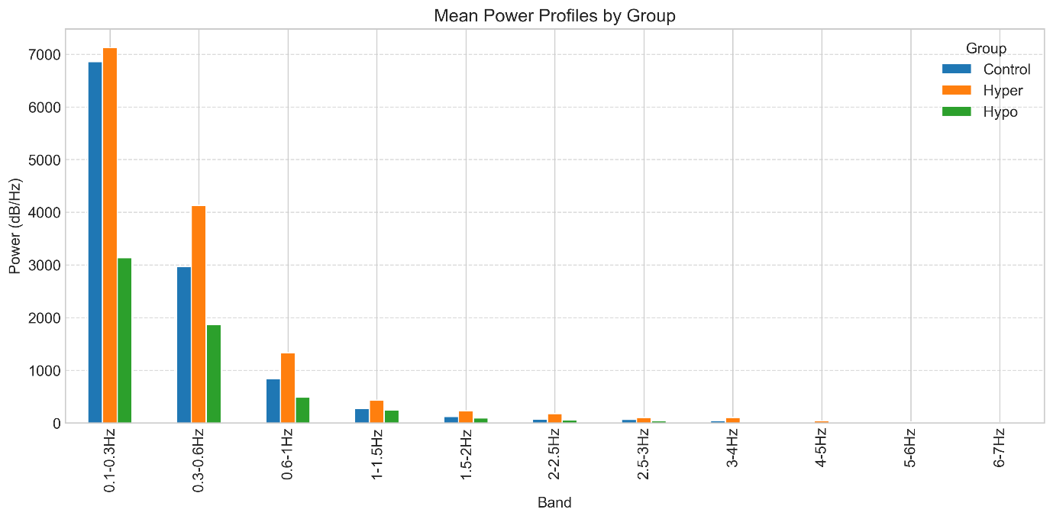

On the figures above one may see that for some patients there is a *visible differentiation* between the power in fine structure of the short frequency spectrum range (0-1Hz), but these differences are inconsistent across the different patients.

**Cross-patient analysis**

For cross-patient analysis on manually labeled spectral regions to determine how consistent these patterns are across different subjects, the sequence is as follows:

1. Data Preprocessing:   
 - Processes data from multiple patients (Insulin Clamp #1-10)  
 - For each patient, extracting power spectra from labeled regions  
 - Focusing on the "Hand" channel, as the one been labeled  
  
2. Consistency Analysis:  
 - Creating matrices of power values across frequency bands for three categories:  
 - Hypo precursor events  
 - Hyper precursor events  
 - Control regions (non-labeled areas)  
 - Calculating coefficient of variation (CV) for each frequency band to measure consistency  
 - Classifying consistency levels (High: CV<15%, Good: CV<30%, Moderate: CV<50%, Low: CV≥50%)  
  
3. Statistical Comparison:  
 - Performing t-tests between groups (hypo vs control, hyper vs control, hypo vs hyper)  
 - Identifying statistically significant differences in frequency bands  
  
4. Visualization:  
 - Heatmaps showing power distributions across patients  
 - Bar plots of consistency metrics for each frequency band  
 - Group comparison plots with significance markers  
 - Detailed analysis of low-frequency bands (0.1-1Hz)  
  
The analysis is intended to identify which frequency bands show the most consistent patterns across patients, which is crucial for developing reliable biomarkers for glycemic event prediction that work across different individuals.

**Results of cross-patient analysis**:

Overall consistency of the labeling is moderate-to-low, most visible differences are in 0-1Hz region. Just as depicted in the first test.

MOST CONSISTENT FREQUENCY BANDS ACROSS PATIENTS:

Hypo Precursors - Top 3 Most Consistent Bands:

0.1-0.3Hz: CV = 41.6% - Moderate Consistency

0.3-0.6Hz: CV = 46.2% - Moderate Consistency

1.5-2Hz: CV = 48.3% - Moderate Consistency

Hyper Precursors - Top 3 Most Consistent Bands:

0.1-0.3Hz: CV = 63.6% - Low Consistency

6-7Hz: CV = 68.0% - Low Consistency

0.3-0.6Hz: CV = 69.3% - Low Consistency

Control Regions - Top 3 Most Consistent Bands:

6-7Hz: CV = 47.3% - Moderate Consistency

5-6Hz: CV = 51.3% - Low Consistency

4-5Hz: CV = 51.3% - Low Consistency

**Overall consistency is low**, and the coefficient of variation is high.

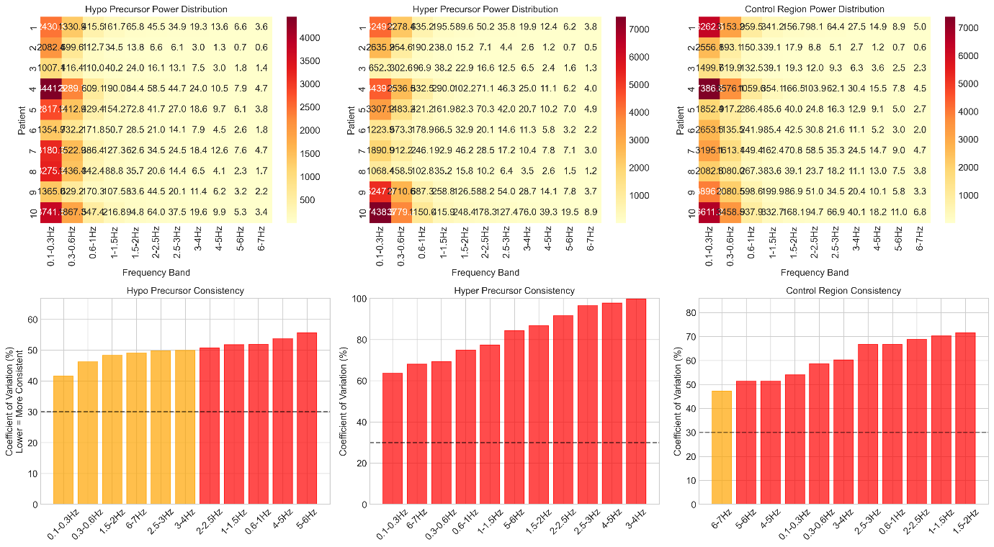

On the following images one can see that while there is a difference between the power per label type across the patients, the variance of the values inside the groups is significant.

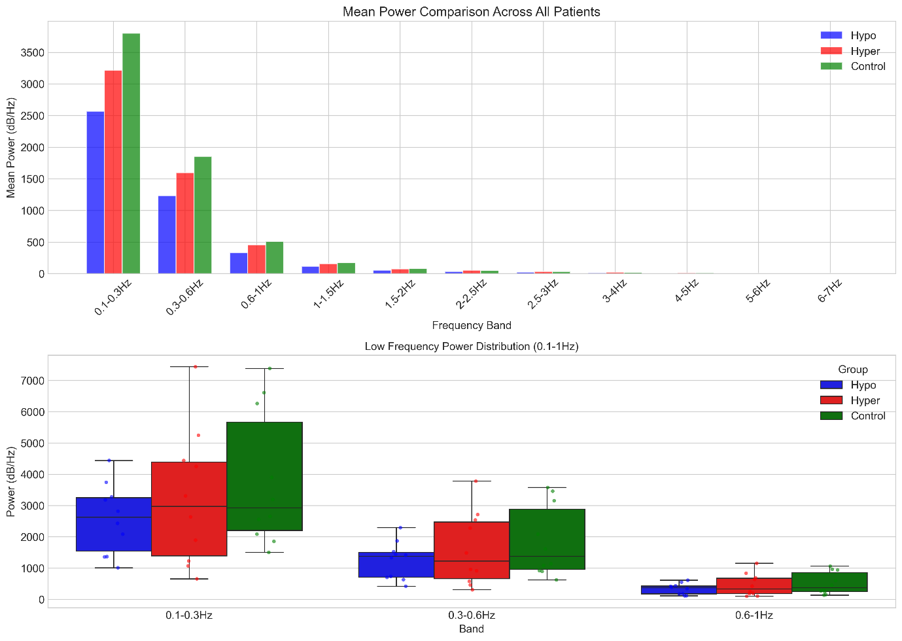

**Summary**

Selected labels, while showing *some discriminant power* across the classes for a specific patient, are not consistent across the different patients.

Either there is a high variability of patterns across the different patients, or the labels represent random motion artifacts, captured by magnetic sensor.